Statistical Process Control (SPC)

What is Statistical Process Control?

SPC is a method of quality control that employs statistical methods to monitor and control a process. Data is analysed over time to understand if a process has special cause and/or common cause variation. SPC can help you understand the scale of any problem, gather information and identify possible causes when used in conjunction with other investigative tools, eg process mapping and spaghetti diagrams. You will then be able to measure the impact of any change and evaluate its worth.

SPC tells us about the variation that exists in the systems that we are looking to improve:
S – statistical, because we use some statistical concepts to help us understand processes.
P – process, because we deliver our work through processes ie how we do things.
C – control, by this we mean predictable.

When and why would I use Statistical Process Control?

SPC can help you understand the scale of any problem, gather information and identify possible causes when used in conjunction with other investigative tools, eg process mapping and spaghetti diagrams. You will then be able to measure the impact of any change and evaluate its worth.

SPC can be used throughout the life cycle of the project to help you identify a baseline and evaluate how you are currently operating. SPC will also help you to assess whether your project has made a sustainable difference. When routinely monitored it can help to flag variation for investigation earlier than it may otherwise have been.

How to use Statistical Process Control

An SPC chart has an average line (mean or median – the mean is most often used in SPC charts) and two control lines above and below the average line, both of which allow more statistical interpretation.

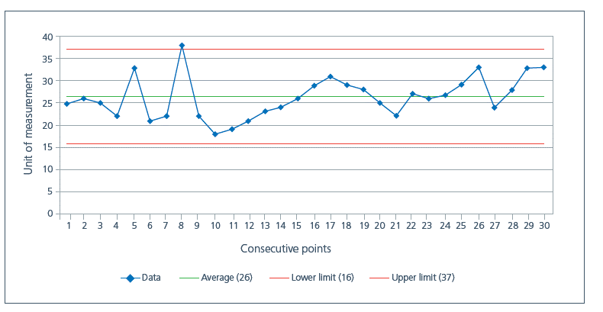
Generally we use specialist software to create SPC charts, but charts can also be easily created using MS Excel. There are four rules to interpret SPC charts and if you use specialist software, these rules will be flagged so you don’t need to remember them. If one of the rules has been broken, this means that special cause variation exists in the system and once identified, can be investigated.
Rule 1 – any single point outside of control limits
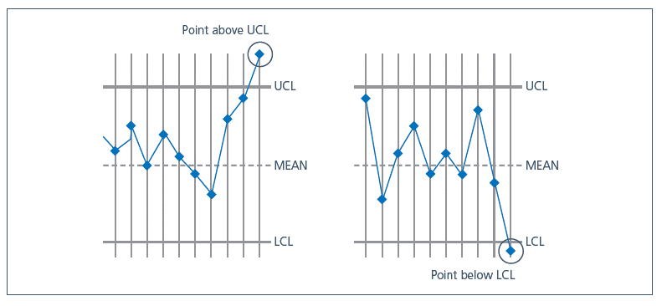
Rule 2 - a run of seven points all above or all below the centre line (a shift), or a run of seven points all consecutively ascending or descending (a drift):
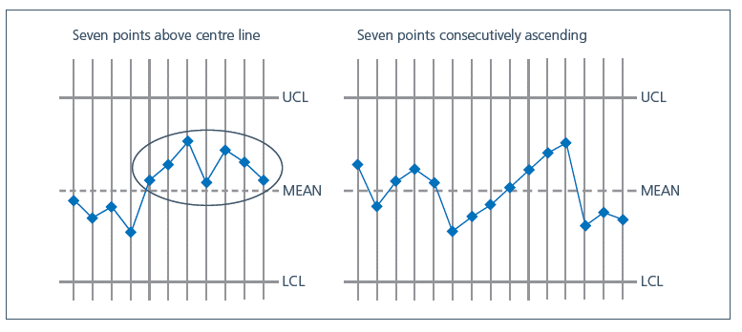
Rule 3 – any unusual pattern or trend within the control limits
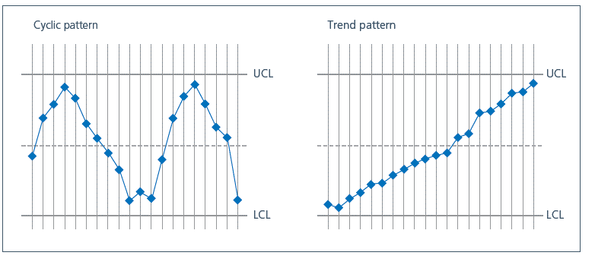
Rule 4 - the number of points within the middle third of the region between the control limits differs markedly from two thirds of the total number of points:
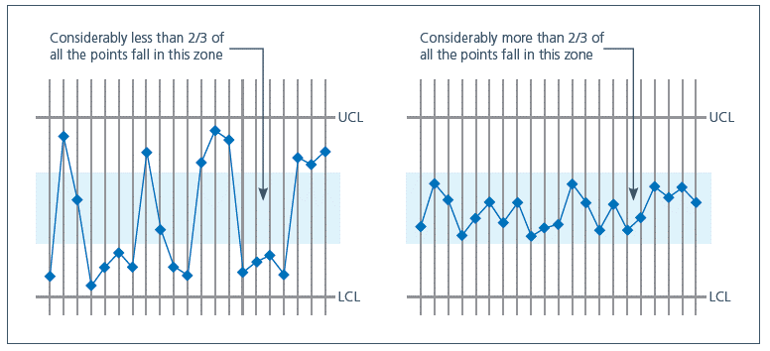

Video Links:
Example of an NHS statistical process control tool (8 mins)
How to create a statistical process control chart (8 mins)
Using SPC for assurance (5 mins)

