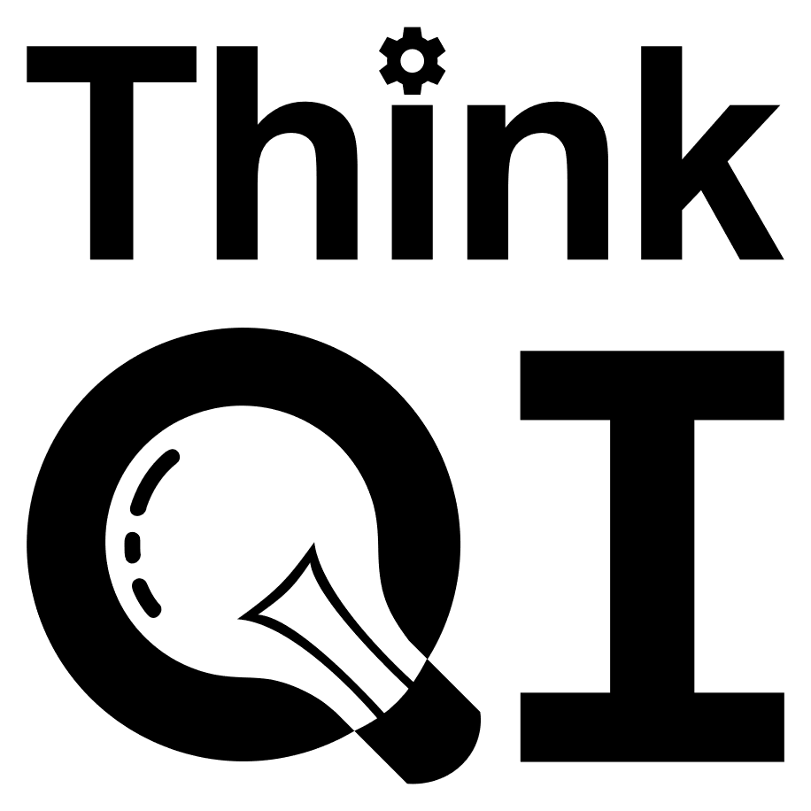**Bridges Model for Change and Transition**

**Endings** – stage 1 – acknowledge, celebrate and value what has been achieved in the past, which can no longer be done – then, explore the new context and emerging way forward – what do people think / feel about it all? What could be the benefits? Take time to allow people to process their thinking – it’s an emotional time

**Neutral zone** – the in-between bit is tough and can take a long time - Stage 2 and 3 – is a stage of ‘holding the team’- as a leader, you are vitally important and using ‘collective leadership’ can get you through this stage – explore more of the new context and emerging way forward – to move forward, stay positive and engage the team, look for how the change can support what is important to the team and their values, look for development opportunities for all in the team and stakeholders, keep going while final solutions are being developed

**New beginnings** - Stage 4 – work as a compassionate, collective and collaborative interdependent team to build and deliver the service, be part of it – expect some re-shifting as the team questions then settles into the new way of being – Tuckman’s Stages of Team Development can shed light on some behaviours during this period

