OPTIONS APPRAISAL GUIDANCE

What is it?
An options appraisal is a decision-making tool used to assess the pros and cons of all proposals against the project objective.

When would I use it?
A formal options appraisal should be used for large scale projects/programmes as these typically involve significant investment both financially and/or from organisational resources. Smaller projects or pieces of work should also explore all options when agreeing the solution, this however might be undertaken in a simpler format. Options should be considered in the design stage of a project.

Why would I use it?
It shows that you have considered a range of alternative options for how your project could be delivered.
It removes individual bias towards certain options and encourages views from all stakeholders on how each option meets the agreed criteria.
A good options appraisal will evidence and support the case for the preferred option by using objective scoring criteria.

Ideally the scoring of the options should be undertaken by a large group of stakeholders which will help to ensure engagement in any proposed business/service change.

What resources are required?

- Options appraisal template
- Options appraisal scorecard.
- Group of key stakeholders!

How would I use it?

Step 1 - Define your project’s objective and outcomes.

This needs to be clear and specific – if you have completed a project charter your objectives and outcomes will be documented there already.

Start detailing this information in the background section of the options appraisal template.

Step 2 - With a group of stakeholders, determine the options available i.e. the different ways that you could achieve your project outcomes.

‘Do Nothing’ must also be included and must remain as an option as this depicts the baseline and the current situation. From this the options paper can be generated.

Record these options on the table in the options appraisal template.

Step 3 - Gather information about the advantages and disadvantages of each option.

During this process some of the options may show no benefits and only a number of risks and issues. These options can be discarded at this stage. However, notes of these discussions should be recorded on the template as these may be required at a later date to show that they were considered.

If you are unsure how to obtain some of this information, ask your colleagues for help.

Step 4 - Agree the benefit criteria to score each option against.

All options will be scored against a number of benefit criteria and the main objective of the change must be one of these.

For example - if a change in service has to happen by a specific date due to a legislative change the following benefit criteria could be used;

- Option completed by date required.
- Option meets all standards required.

Some of the options will meet these criteria more than others and that is how they will be scored. It is not unusual to see benefits relating to cost and time, but also other factors such as strategic fit and impact on other services should be considered.

Step 5 - Award each benefit criteria a weighted score.

Each of the benefit criteria will then need to be awarded a weighted score dependent upon its importance. The weighted scores must total 100 to enable the score sheet to give each option a final percentage score.

The way to work this out is to rank the benefit criteria in order of importance with the group. It may be that some of the benefit criteria are ranked the same or similar in which case you can give them the same weighting.

For example, the benefit criteria below have been listed in order of importance, the weighted score used reflects how importance placed on each:

Weighted score
Positive User Experience 40
Access to Care/Services 30
Best Use of Resources 15
Quality of Accommodation 15

Further advice and assistance will be given by the Improvement and Transformation Office upon request.

Step 6 - Assess each option using your system.

Populate the scorecard with the benefit criteria and weighted scores.
Before sending to a wider stakeholder group - test the scorecard and criteria used with a small group of colleagues.

Issue out to stakeholders with a deadline for return.

Step 7 - Analyse the scoring results.

Collate all scorecards, ensuring that all stakeholder groups have had the opportunity to score and comment.

Compile information on to the options appraisal template.

Step 8 - Submit the options appraisal report with preferred option selected to appropriate group/forum.

What next?

Once a preferred option has been selected it’s time to plan implementation!

OPTIONS APPRAISAL PAPER TEMPLATE

<Project Name>

<Author>
<Version>

DOCUMENT CONTROL

VERSION | DATE | AUTHOR | COMMENTS

Options to Consider

Background
Insert…
(Give a brief background to the reason why and the objectives of the options appraisal, including operational or compliance drivers. Consider all options no matter how radical).

Agree the benefit criteria upon which the options can be scored (see scoring section of this guide below). Include your benefits criteria as column headings to enable you to consider the impact on these fully when assessing your options. The following column headings might also be suitable, depending on your objectives.

- Cost – Enter full costs of option both revenue and capital. If estimated state this.
- Timescale - Enter full timescale for delivery of each option.
- Impact v effort - Indicate high or low for both the impact of change and effort to implement
- Benefits - Enter all the benefits for the option including financial. Also consider any potential benefits to stakeholders and other groups.

You can add/remove columns as appropriate to your project objectives.

Example:
Option | Achievable by April 2022 | Affordability | Improved quality & environment for patients | Improved privacy and dignity for patients | Maintains clinical zoning | Improvement to infection control measures | Risks/Issues
Give full description of each option including any phased implementation breakdown to inform the reader fully of what is being proposed | Yes/No (plus provide any other relevant information regarding timescales) | Provide details of costs and budget as appropriate | Indicate if positive or negative | Indicate if positive or negative | Indicate if positive or negative | Indicate if positive or negative | Enter all perceived risks and issues for the option including:  - Possible maximum penalties financial or operational  - Risks scored against risk matrix  - To other groups or stakeholders
1. Do Nothing
Do Nothing must always be included as an option if only as a benchmark with which to measure other options.

2.
3.
4.

5.

Summary of Viable Options

After considering all risks and benefits above enter a brief summary (cut & paste) of each option from the main options paper as an exec summary of main options.

Option | Shortlist
 | YES | NO

1. |  | X
2.

3.

4.

5.

Options Appraisal (Scoring)

Once the options have been developed form a small group of key stakeholders and agree weighting for each benefit criteria which must total 100.

Example Benefit Criteria and Weighting

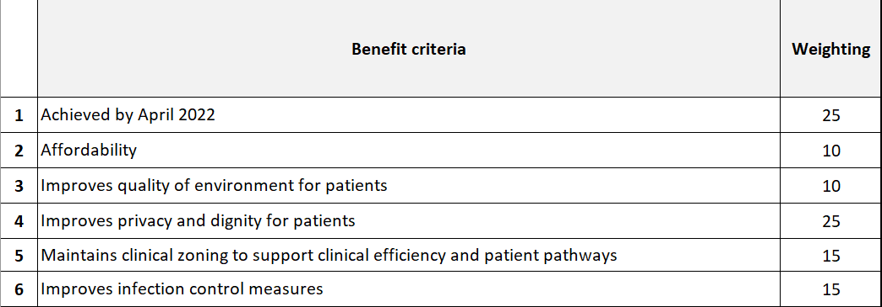

The options can then be scored using the RAW scoring as below, the RAW scores should be entered onto the scoring matrix which will automatically generate a percentage score for each option, see example.

Raw Scoring Guide

0 – Unacceptable Option cannot meet minimum required performance.
1 – Poor Effort required to enable option to meet minimum required performance.
2 – Acceptable Option meets minimum required performance.
3 – Good Option exceeds minimum required performance.
4 – Very Good Option provides additional useful benefits in addition to exceeding minimum required performance.

Example Scoring Matrix

It is important to get as many stakeholders as possible to score the options and final scores can be entered into a matrix which will give the median scores of all who have returned a scored matrix. Score each of the options using the RAW scoring against the benefits criteria and enter the number from 0-4 in each yellow box…

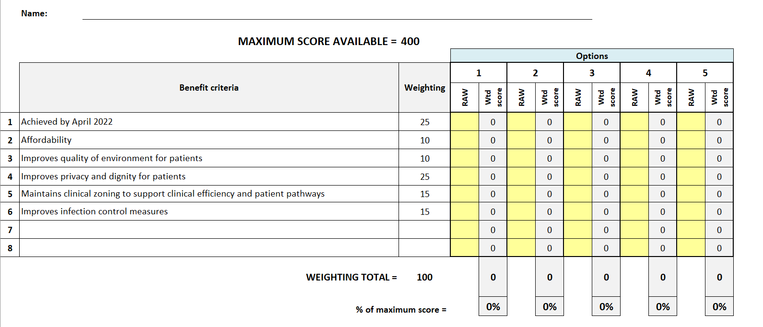

Options Scorecard Template

Populate the Excel scorecard linked below with benefits criteria and weighted scores before circulating with your stakeholders with a deadline for completion and return.

